Mouhammadou Dabo

February 4, 2021

CS 1675: Intro to Machine Learning

Professor Milos Hauskrecht

Handout 1 – Problem Assignment

**Problem 1. Matrix operations**

* *uT * u =* 26
* *u * uT =*
* *v * u =* 71
* *u + 5 =*
* *AT =*
* *B * u =*
* *B−1 =*
* *B + C =*
* *B – C =*
* *A * B = $\begin{matrix}31 & 45 & 45 \\ 53 & 59 & 75\end{matrix}$*
* *B * C = $\begin{matrix}48 & 21 & 75 \\ 15 & 0 & 30 \\ 34 & -12 & 76\end{matrix}$*
* *B * A* – Error using * - Incorrect dimensions for matrix multiplication. Check that the number of columns in the first matrix matches the number of rows in the second matrix.

**Problem 2. Exploratory data analysis**

* Number of times pregnant
  + Min value: 0
  + Max value: 17
* Plasma glucose concentration a 2 hours in an oral glucose tolerance test
  + Min value: 0
  + Max value: 199
* Diastolic blood pressure (mm Hg)
  + Min value: 0
  + Max value: 122
* Triceps skin fold thickness (mm)
  + Min value: 0
  + Max value: 99
* 2-Hour serum insulin (mu U/ml)
  + Min value: 0
  + Max value: 846
* Body mass index (weight in kg/(height in m)^2)
  + Min value: 0
  + Max value: 67.1
* Diabetes pedigree function
  + Min value: 0.078
  + Max value: 2.4
* Age (years)
  + Min value: 21
  + Max value: 81
* Class variable (0 or 1)
  + Min value: 0
  + Maxi value: 1
* Number of times pregnant
  + Mean value: 3.8451
  + STD value: 3.3696
* Plasma glucose concentration a 2 hours in an oral glucose tolerance test
  + Mean value: 120.8945
  + STD value: 31.9726
* Diastolic blood pressure (mm Hg)
  + Mean value: 69.1055
  + STD value: 19.3558
* Triceps skin fold thickness (mm)
  + Mean value: 20.5365
  + STD value: 15.9522
* 2-Hour serum insulin (mu U/ml)
  + Mean value: 79.7995
  + STD value: 115.2440
* Body mass index (weight in kg/(height in m)^2)
  + Mean value: 31.9926
  + STD value: 7.882
* Diabetes pedigree function
  + Mean value: 0.4719
  + STD value: 0.3313
* Age (years)
  + Mean value: 32.2409
  + STD value: 11.7602
* Class variable (0 or 1)
  + Mean value: 0.3490
  + STD value: 0.477

Label 0

* Number of times pregnant
  + Mean value: 3.298
  + STD value: 3.0172
* Plasma glucose concentration a 2 hours in an oral glucose tolerance test
  + Mean value: 109.98
  + STD value: 26.1412
* Diastolic blood pressure (mm Hg)
  + Mean value: 68.184
  + STD value: 18.0631
* Triceps skin fold thickness (mm)
  + Mean value: 19.664
  + STD value: 14.8899
* 2-Hour serum insulin (mu U/ml)
  + Mean value: 68.7920
  + STD value: 98.8653
* Body mass index (weight in kg/(height in m)^2)
  + Mean value: 30.3042
  + STD value: 7.6899
* Diabetes pedigree function
  + Mean value: 0.4297
  + STD value: 0.2991
* Age (years)
  + Mean value: 31.1900
  + STD value: 11.6677

Label 1

* Number of times pregnant
  + Mean value: 4.8657
  + STD value: 3.7412
* Plasma glucose concentration a 2 hours in an oral glucose tolerance test
  + Mean value: 141.2575
  + STD value: 31.9396
* Diastolic blood pressure (mm Hg)
  + Mean value: 70.8246
  + STD value: 21.4918
* Triceps skin fold thickness (mm)
  + Mean value: 22.1642
  + STD value: 17.6797
* 2-Hour serum insulin (mu U/ml)
  + Mean value: 100.3358
  + STD value: 138.6891
* Body mass index (weight in kg/(height in m)^2)
  + Mean value: 35.1425
  + STD value: 7.2630
* Diabetes pedigree function
  + Mean value: 0.5505
  + STD value: 0.3724
* Age (years)
  + Mean value: 37.0672
  + STD value: 10.9683

The attribute that would be most helpful in discriminating the two classes is the 2-Hour serum insulin, since it is the only attribute with a big variance between the two classes.

1. The histogram that resembles most the normal distribution is the histogram of attribute 6.

The other histogram that resembles a normal distribution is the histogram of attribute 3.

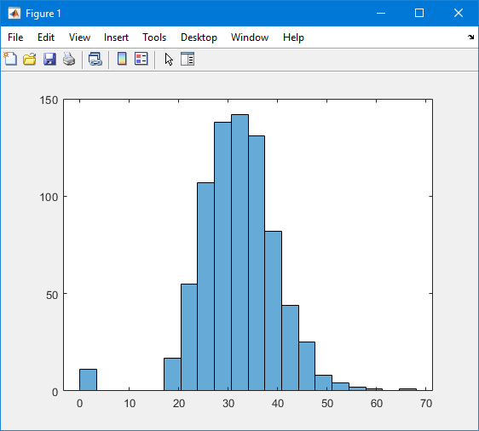**Histogram for Attribute 6**

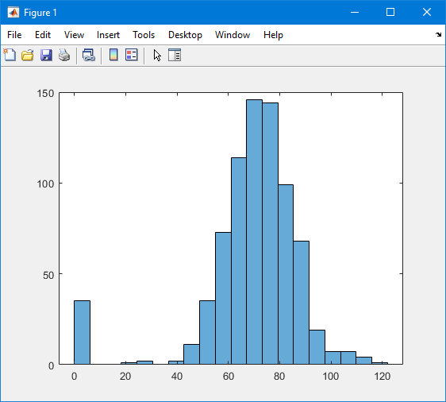**Histogram for Attribute 3**

1. Based on the pairs of histograms, the attribute I think is the most helpful in discriminating the two classes would be Attribute 2 (Plasma glucose concentration a 2 hours in an oral glucose tolerance test), since the range between the two classes are very different.

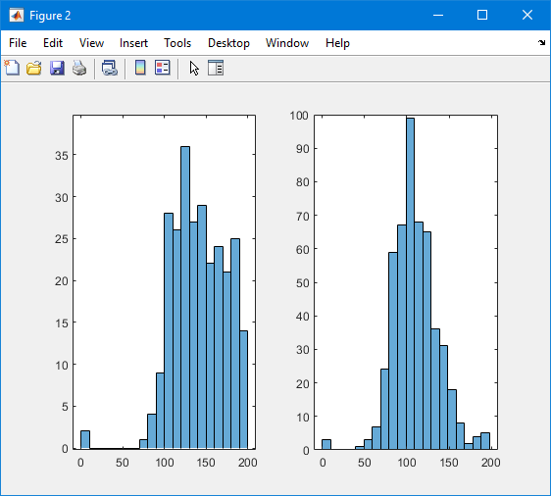

**Problem 3. Data preprocessing**

{brown, blue, white, red, yellow, orange, green, black}

* Brown: (1, 0, 0, 0, 0, 0, 0, 0);
* Blue: (0, 1, 0, 0, 0, 0, 0, 0);
* White: (0, 0, 1, 0, 0, 0, 0, 0);
* Red: (0, 0, 0, 1, 0, 0, 0, 0);
* Yellow: (0, 0, 0, 0, 1, 0, 0, 0);
* Orange: (0, 0, 0, 0, 0, 1, 0, 0);
* Green: (0, 0, 0, 0, 0, 0, 1, 0);
* Black: (0, 0, 0, 0, 0, 0, 0, 1);

Since there are 8 different categories, I used a vector of size 8 with binary values

$$\left[\begin{matrix}red \\ black \\ yellow \\ red \\ green \\ blue \\ blue\end{matrix}\right]$$

= $$\left[\begin{matrix}0, 0, 0, 1, 0, 0, 0, 0 \\ 0, 0, 0, 0, 0, 0, 0, 1 \\ 0, 0, 0, 0, 1, 0, 0, 0 \\ 0, 0, 0, 1, 0, 0, 0, 0 \\ 0, 0, 0, 0, 0, 0, 1, 0 \\ 0, 1, 0, 0, 0, 0, 0, 0 \\ 0, 1, 0, 0, 0, 0, 0, 0\end{matrix}\right]$$

Attribute 3 - Diastolic blood pressure (mm Hg)

* Mean value: 69.1055
* STD value: 19.3558
* First Five Normalized Values:
  + 0.1495
  + -0.1604
  + -0.2638
  + -0.1604
  + -1.5037

Entry 1: Bin 6

Entry 2: Bin 6

Entry 3: Bin 5

Entry 4: Bin 6

Entry 5: Bin 4